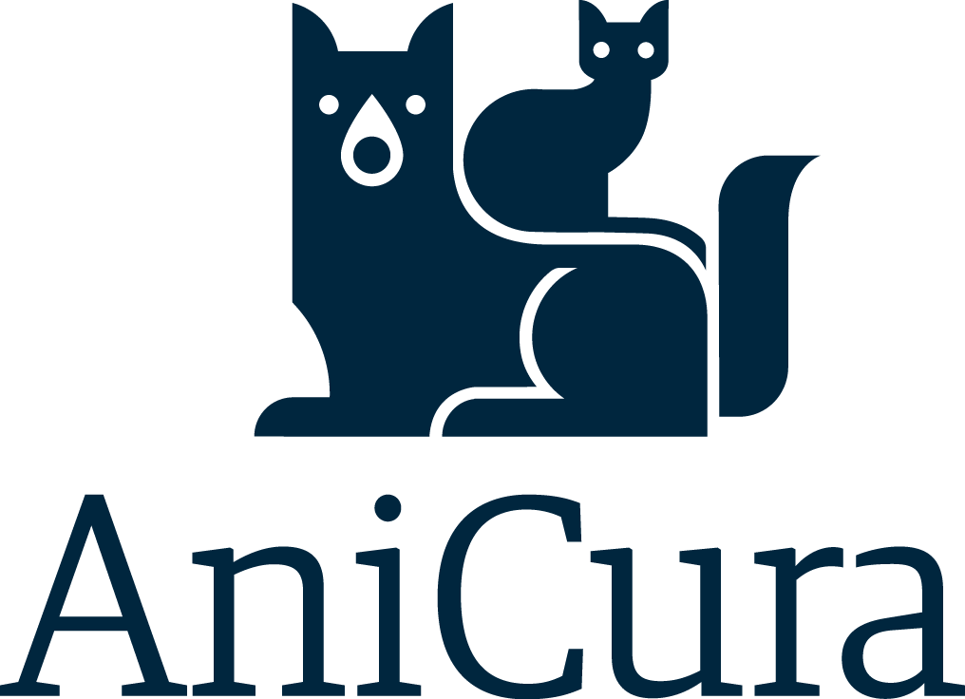
Veterinary Referral Ophthalmologist – Join our Team in Hamburg!
Do you want to be part of and grow an ophthalmology referral service in the northern part of Germany? Our AniCura Vet Specialist Hamburg GmbH is looking for a full-time veterinary ophthalmologist to join our ophthalmology service. This is a unique opportunity to be part of a traditional and highly respected service in Northern Germany.
Who We Are:
AniCura is a family of renowned veterinary clinics and practices specializing in the veterinary care of companion animals. We treat over 4.5 million patients annually in more than 490 clinics and practices across Europe. It is AniCura’ s ambition to provide the highest level of veterinary care. Therefore, we invest heavily in continuous training and skills development for all our staff, as well as in research and complex technical equipment for diagnostics and treatment.
AniCura Germany now has more than 80 locations and over 3,000 employees. Every single team member contributes significantly to increasing AniCura’ s success in Germany and setting new standards. Together, we are shaping the veterinary medicine of tomorrow!
What We Offer:
- A chance to really make a difference and help to transform a well-known service into the future
- A supportive and friendly team who will truly make you feel valued!
- Full ophthalmic equipment including operating microscope, ERG, Phaco, Diode laser etc.
- Competitive Salary, corporate benefits, e.g. Job bike, access to the Corporate Benefits platform with discounts from over 700 providers, givve Card (personalized Mastercard with a €50 credit per month), company pension plan
- Weekends OFF, no night-time shifts
What we expect:
- A qualified ophthalmologist, either at Advanced Practitioner level, Residency-trained board- eligible, or a Diplomate
- Must fundamentally be a great person to work with, and not only be a fabulous ophthalmologist, but warm and approachable with clients.
- You can be full-time (4-5 days a week) or part-time (1-3 days per week)

If you’re looking for a role which combines a great working environment, live the most interesting city of Germany, and be part of traditional well-known and expanding service: Please check out our website and get in touch!
To apply or learn more, contact our Senior Talent Acquisition Manager Laura: laura.miklautsch@anicura.de

